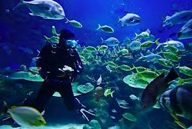
Graduate Lake Shore High School with a 4.0
Skydive
Become a professional soccer player
Deep sea diving
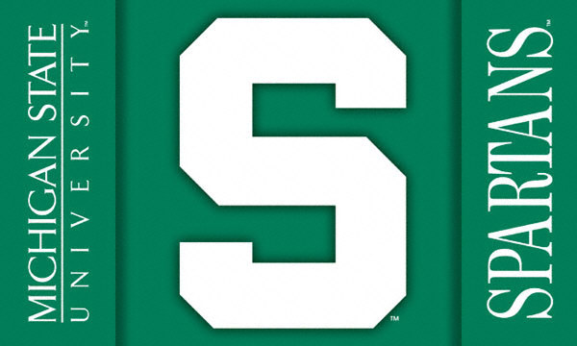
Go to Italy
Go to a Manchester united soccer game
Go to Michigan State
Meet Ronaldinho
Meet Wiz Khalifa
Go on a road trip with my friends

